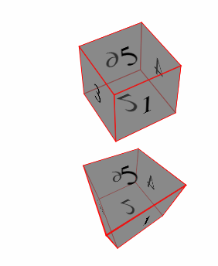<!DOCTYPE html>

<html>

<head>

<style>

.ex1 {

perspective: 800px;

}

.ex2 {

perspective: 150px;

}

.cube {

font-size: 4em;

width: 2em;

margin: 1.5em auto;

transform-style: preserve-3d;

transform: rotateX(-45deg) rotateY(30deg);

}

.side {

position: absolute;

width: 2em;

height: 2em;

background: rgba(100, 100, 100, 0.5);

border: 1px solid red;

text-align: center;

line-height: 2em;

}

.front { transform: translateZ(1em); }

.top { transform: rotateX(90deg) translateZ(1em); }

.right { transform: rotateY(90deg) translateZ(1em); }

.left { transform: rotateY(-90deg) translateZ(1em) }

.bottom {transform: rotateX(-90deg) translateZ(1em); }

.back { transform: rotateY(-180deg) translateZ(1em); }

</style>

</head>

<body>

<h1>The perspective Property</h1>

<h2>perspective: 800px:</h2>

<div class="ex1">

<div class="cube">

<div class="side front">1</div>

<div class="side back">6</div>

<div class="side right">4</div>

<div class="side left">3</div>

<div class="side top">5</div>

<div class="side bottom">2</div>

</div>

</div>

<br><br><br><br><br><br><br><br><br>

<h2>perspective: 150px:</h2>

<div class="ex2">

<div class="cube">

<div class="side front">1</div>

<div class="side back">6</div>

<div class="side right">4</div>

<div class="side left">3</div>

<div class="side top">5</div>

<div class="side bottom">2</div>

</div>

</div>

</body>

</html>